# ASSIGNMENT-2.1 :-

Step 22:- 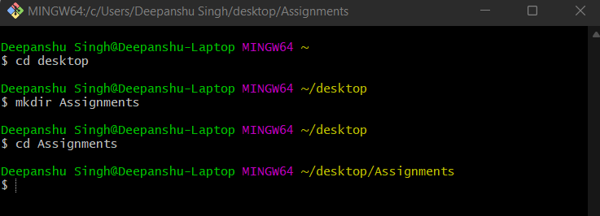

Step 23 & 24:- Done but forgot to take ss.

Step 25:-

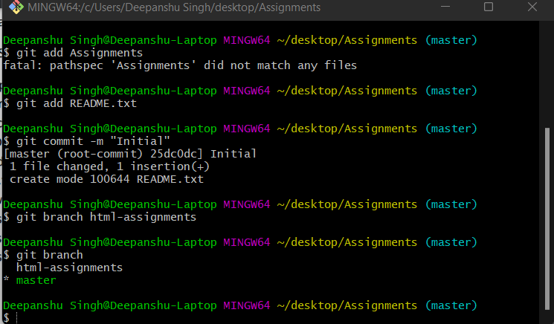

Step 26:-

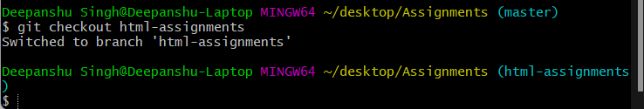

Step 27 & 28:-

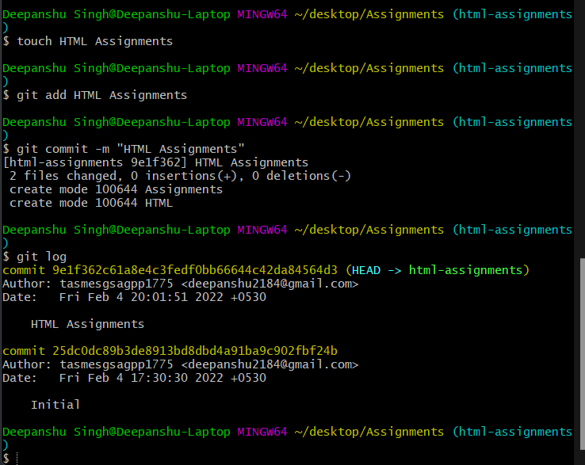

Step 29:- 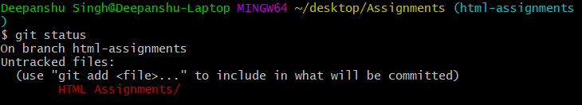

Step 30:- 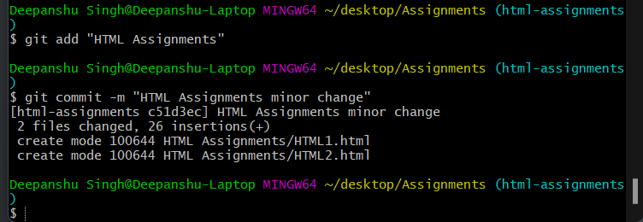

Step 31:-

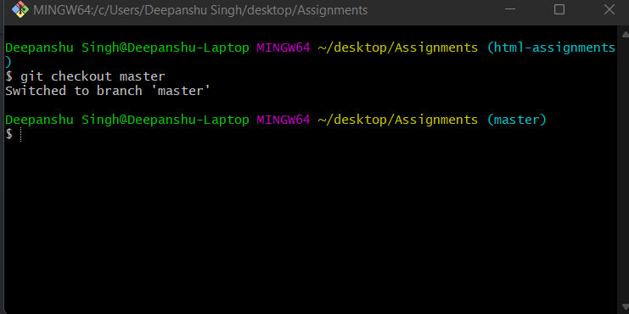

Step 32 & 33:- 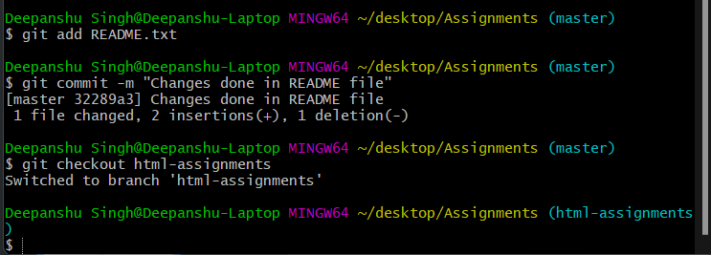

Step 34&35:-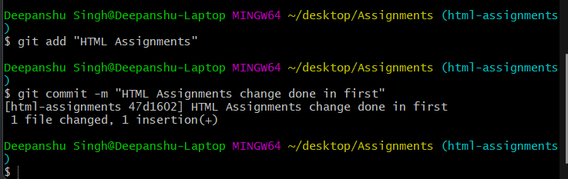

Step 36:- 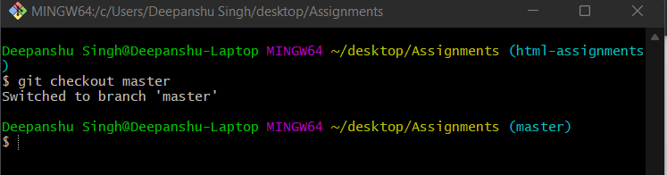

Step 37:- 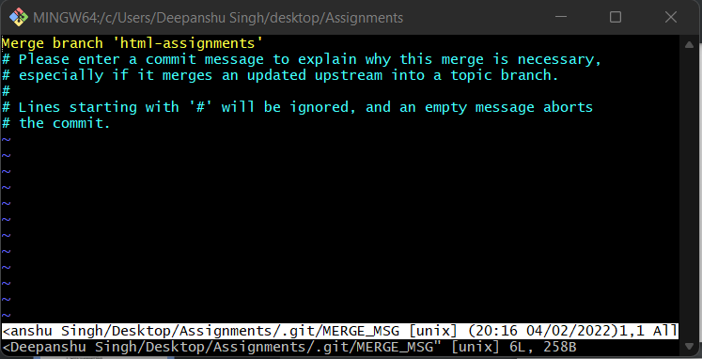

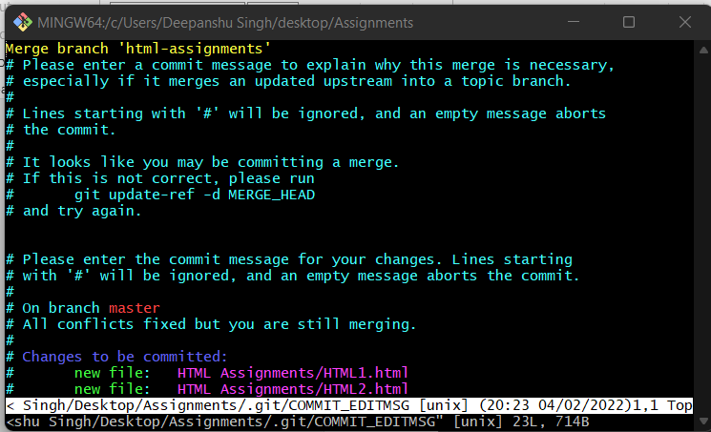

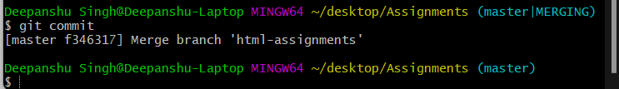

Step 38:- 